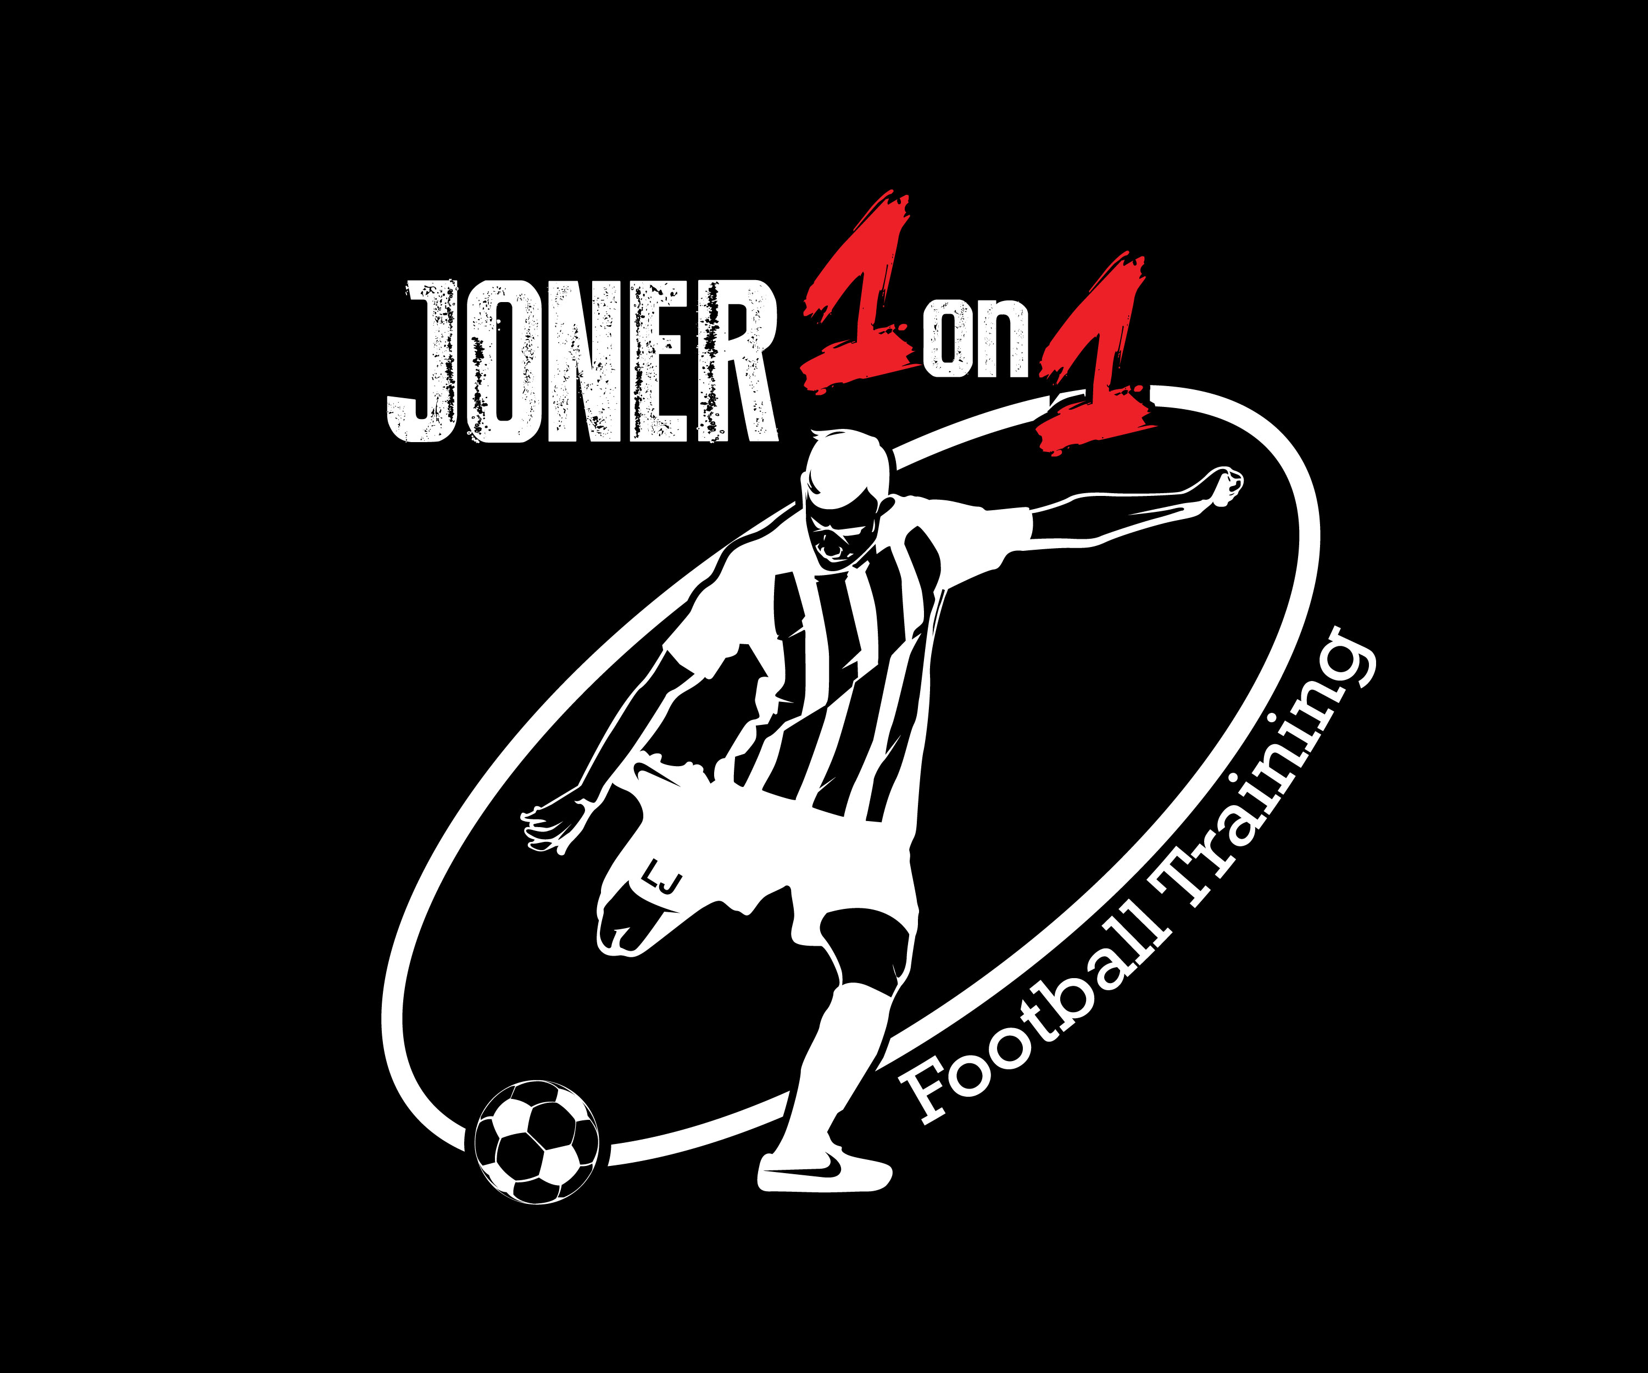
Joner1on1 Football Training Elite Camp – Waiver form

This training agreement sets out terms and conditions on which both player and coach hereby agree to during our Elite Camp.

Payment terms

- Payment for Joner 1on1 camp must be payed before the camp starts.

Participant Information

Participant Name ________________________________________________________
Parent(s)/Guardian(s) Name _______________________________________________
Home Phone ______________________ Alt/Mobile________________________
Emergency Contact Name & Phone ________________________________________

Participant Waiver & Liability Agreement
I understand that there are risks associated with playing all sports and field related activities. In consideration for the privilege to use the facility and/or attend the camp/clinic, my signature indicates that I assume the risk of any injuries that myself or my children/wards may sustain while participating in any activity at the Joner1on1 Elite camps and for any injuries which myself or my children/wards may sustain while on the premises of the Joner 1on1 Elite Camps, I insure that I am or my child is physically and mentally able to participate in physical activities and have been examined by a licensed medical physician within one (1) year prior to attending this clinic/camp.

I give permission for camp trainers and coaches or contracted health care to start preliminary treatment and arrange transportation for me or my child to a local Emergency Room in the event that my child or I become(s) ill or injured.

By signing this training agreement you give permission either for yourself or on behalf of a minor as a legal guardian for Joner1on1 Football training to use images and video footage taken during the camp to be used by Joner1on1football training through social media and advertisement.

By signing this Waiver and Liability Agreement, I acknowledge that I HAVE READ AND FULLY UNDERSTAND AND AGREE TO ALL OF ITS TERMS AND CONDITIONS INCLUDING PERMISION TO TREAT AGREEMENT. I further state that I have executed this waiver and liability voluntarily and with full knowledge of its significance to be binding on my, my heirs, executors, administrators and assigns.

_____________________________________________ _______________
Participant’s Signature (Parent/Guardian if under 18) Date

